Task No. 01: Write step to install visual studio.

STEPS:

1. Search Virtual Studio on Internet and click on the Link as shown in picture:

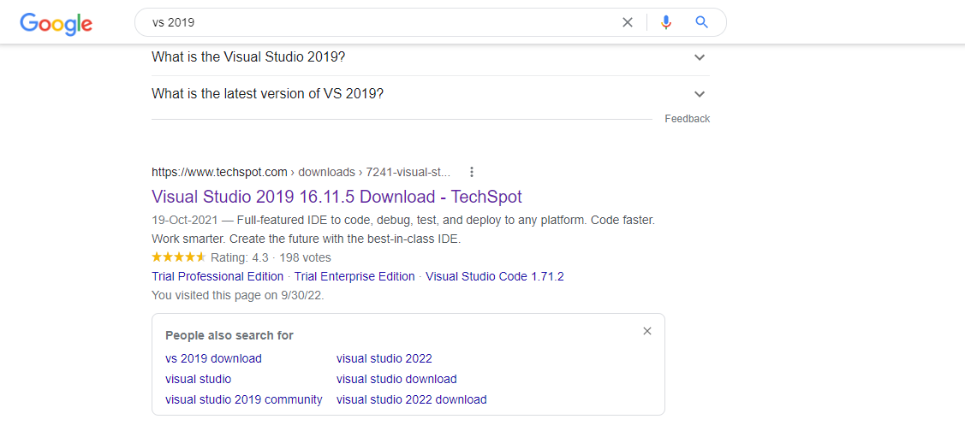

1. Click on Free Community Edition and Downloading will start:

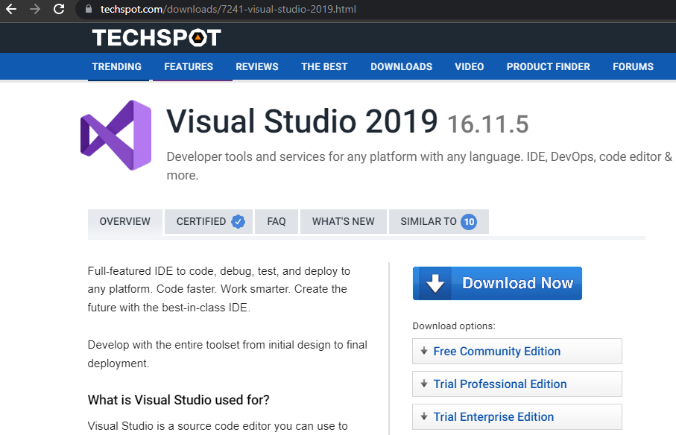

1. Now open installation package and Download Visual Studio:

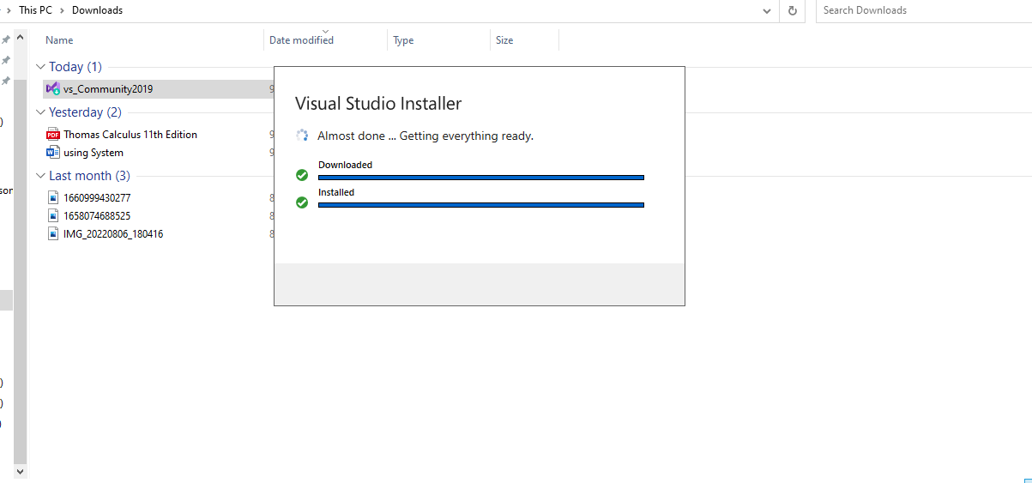

1. Now open the visual studio installer and Download .NET desktop Development:

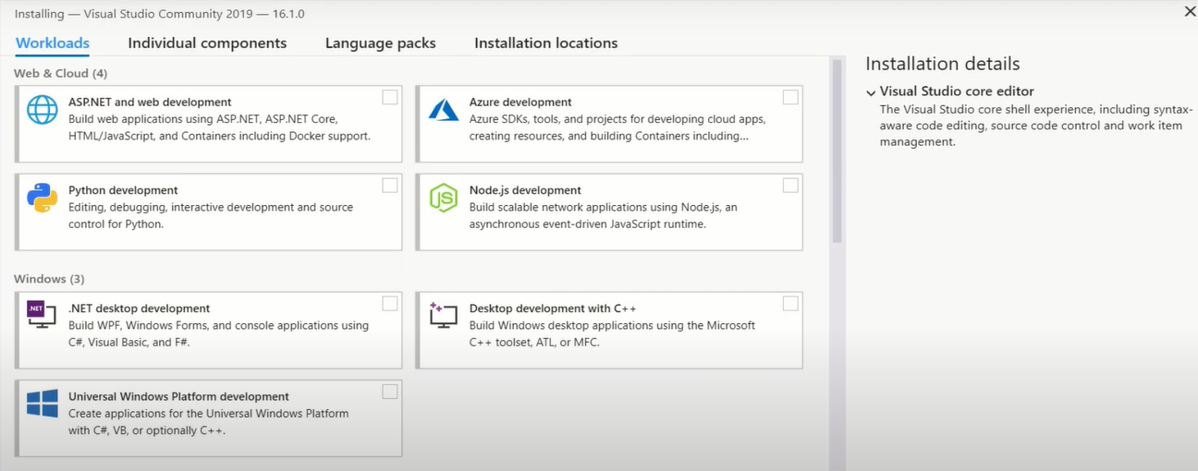

1. Visual Studio Will start automatically once it is Downloaded